**My Creative Coding Project.**

* ***Inspiration from other artists…***

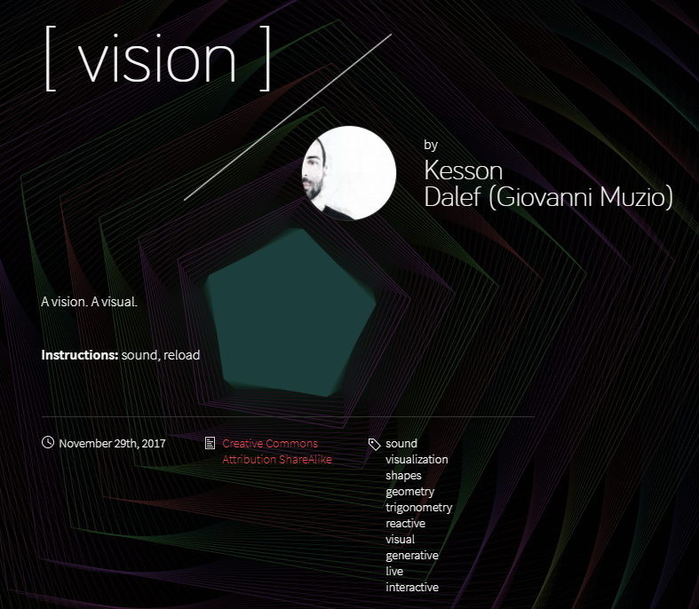

*Some inspiration came from the work of this artist, ‘Kesson Dalef’. His work uses the sounds picked up by a microphone to produce a varying intensity of hexagons made up of a multitude of lines. I felt this was something I wanted to try and explore so here is where my initial idea to use lines came to mind.*

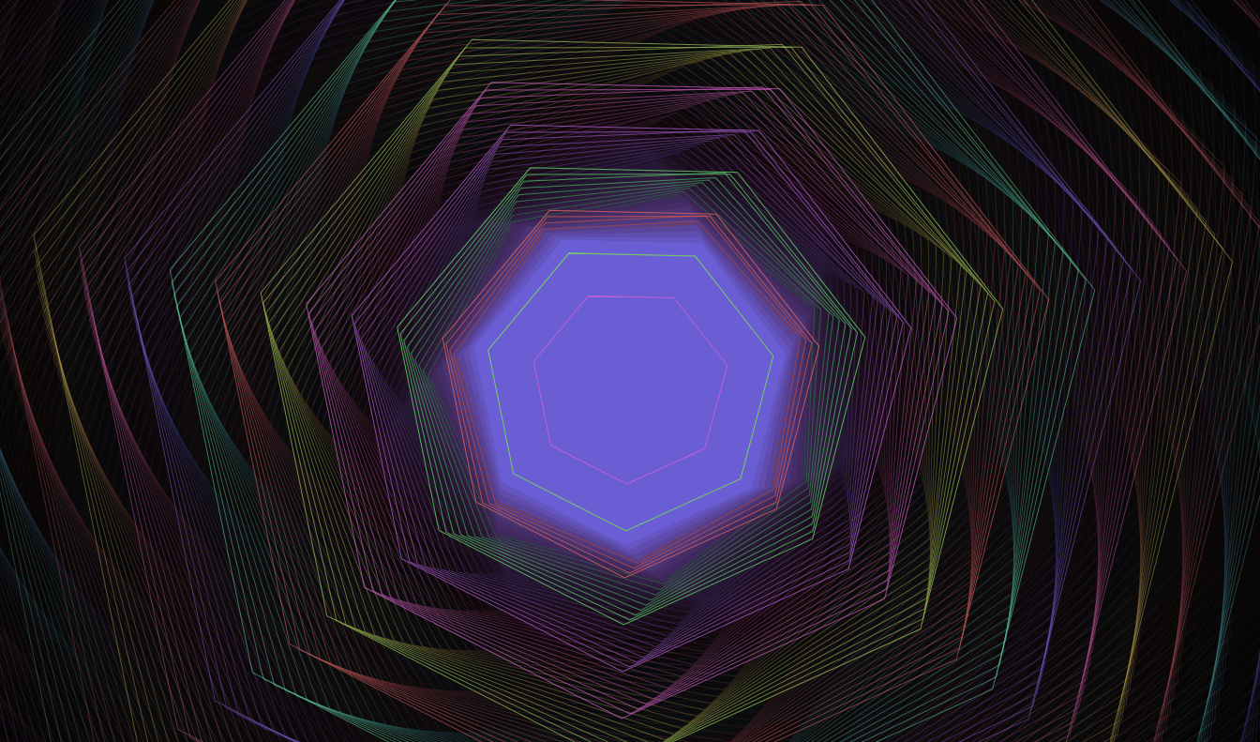

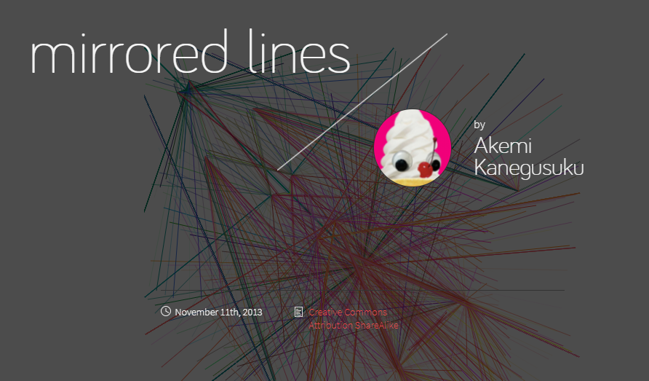

*This was my second source of inspiration, I decided to explore a little more into the use of lines and came across this artist that uses a mirrored effect to reflect coloured lines based off of where the user is clicking their mouse. I knew I would be able to achieve something similar to this after covering something similar to this in a prior lecture.*

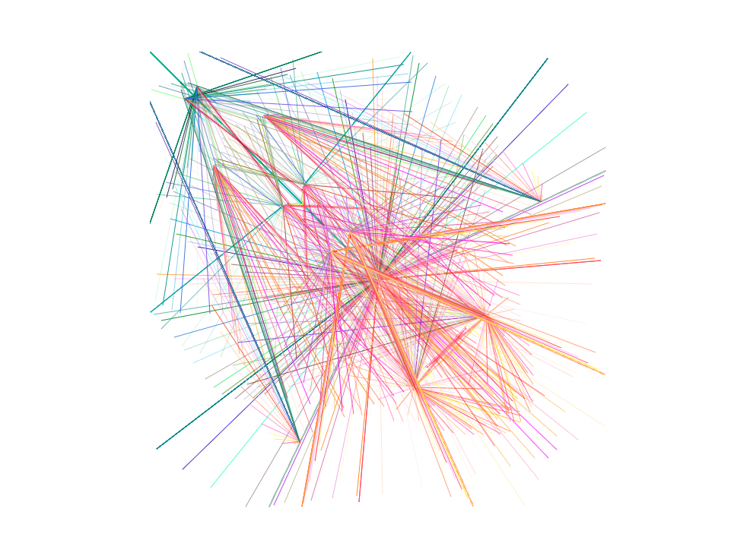

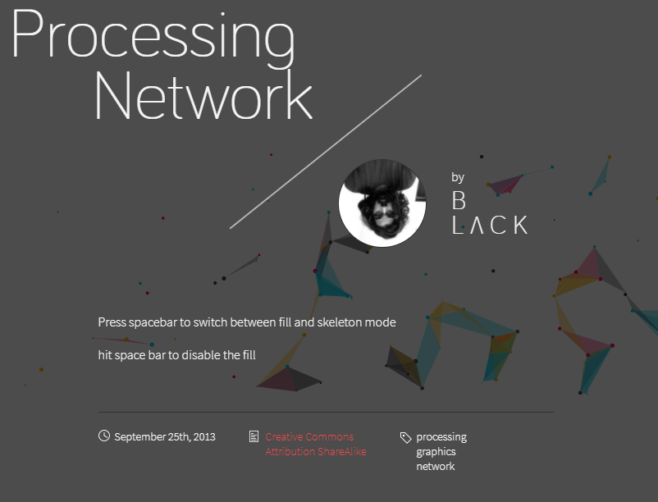

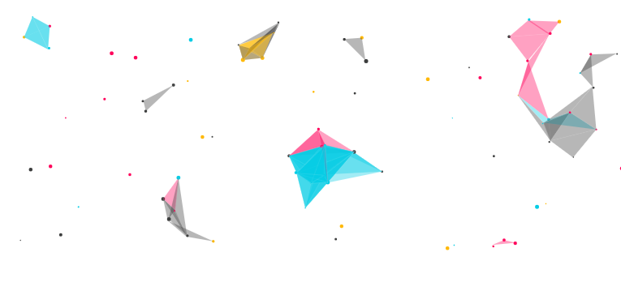

*This was another example of creative coding that I found to be intreaging. The simplicity of bouncing spheres that connected when near to one another, to create a shape that was responsive to each of their position. Again, I had had expirence with creating a very basic project in a previouse lecutre that was based around ‘bouncing spheres’. So I began trying to combine an element from each of these into one project.*

* ***My process and Issues***

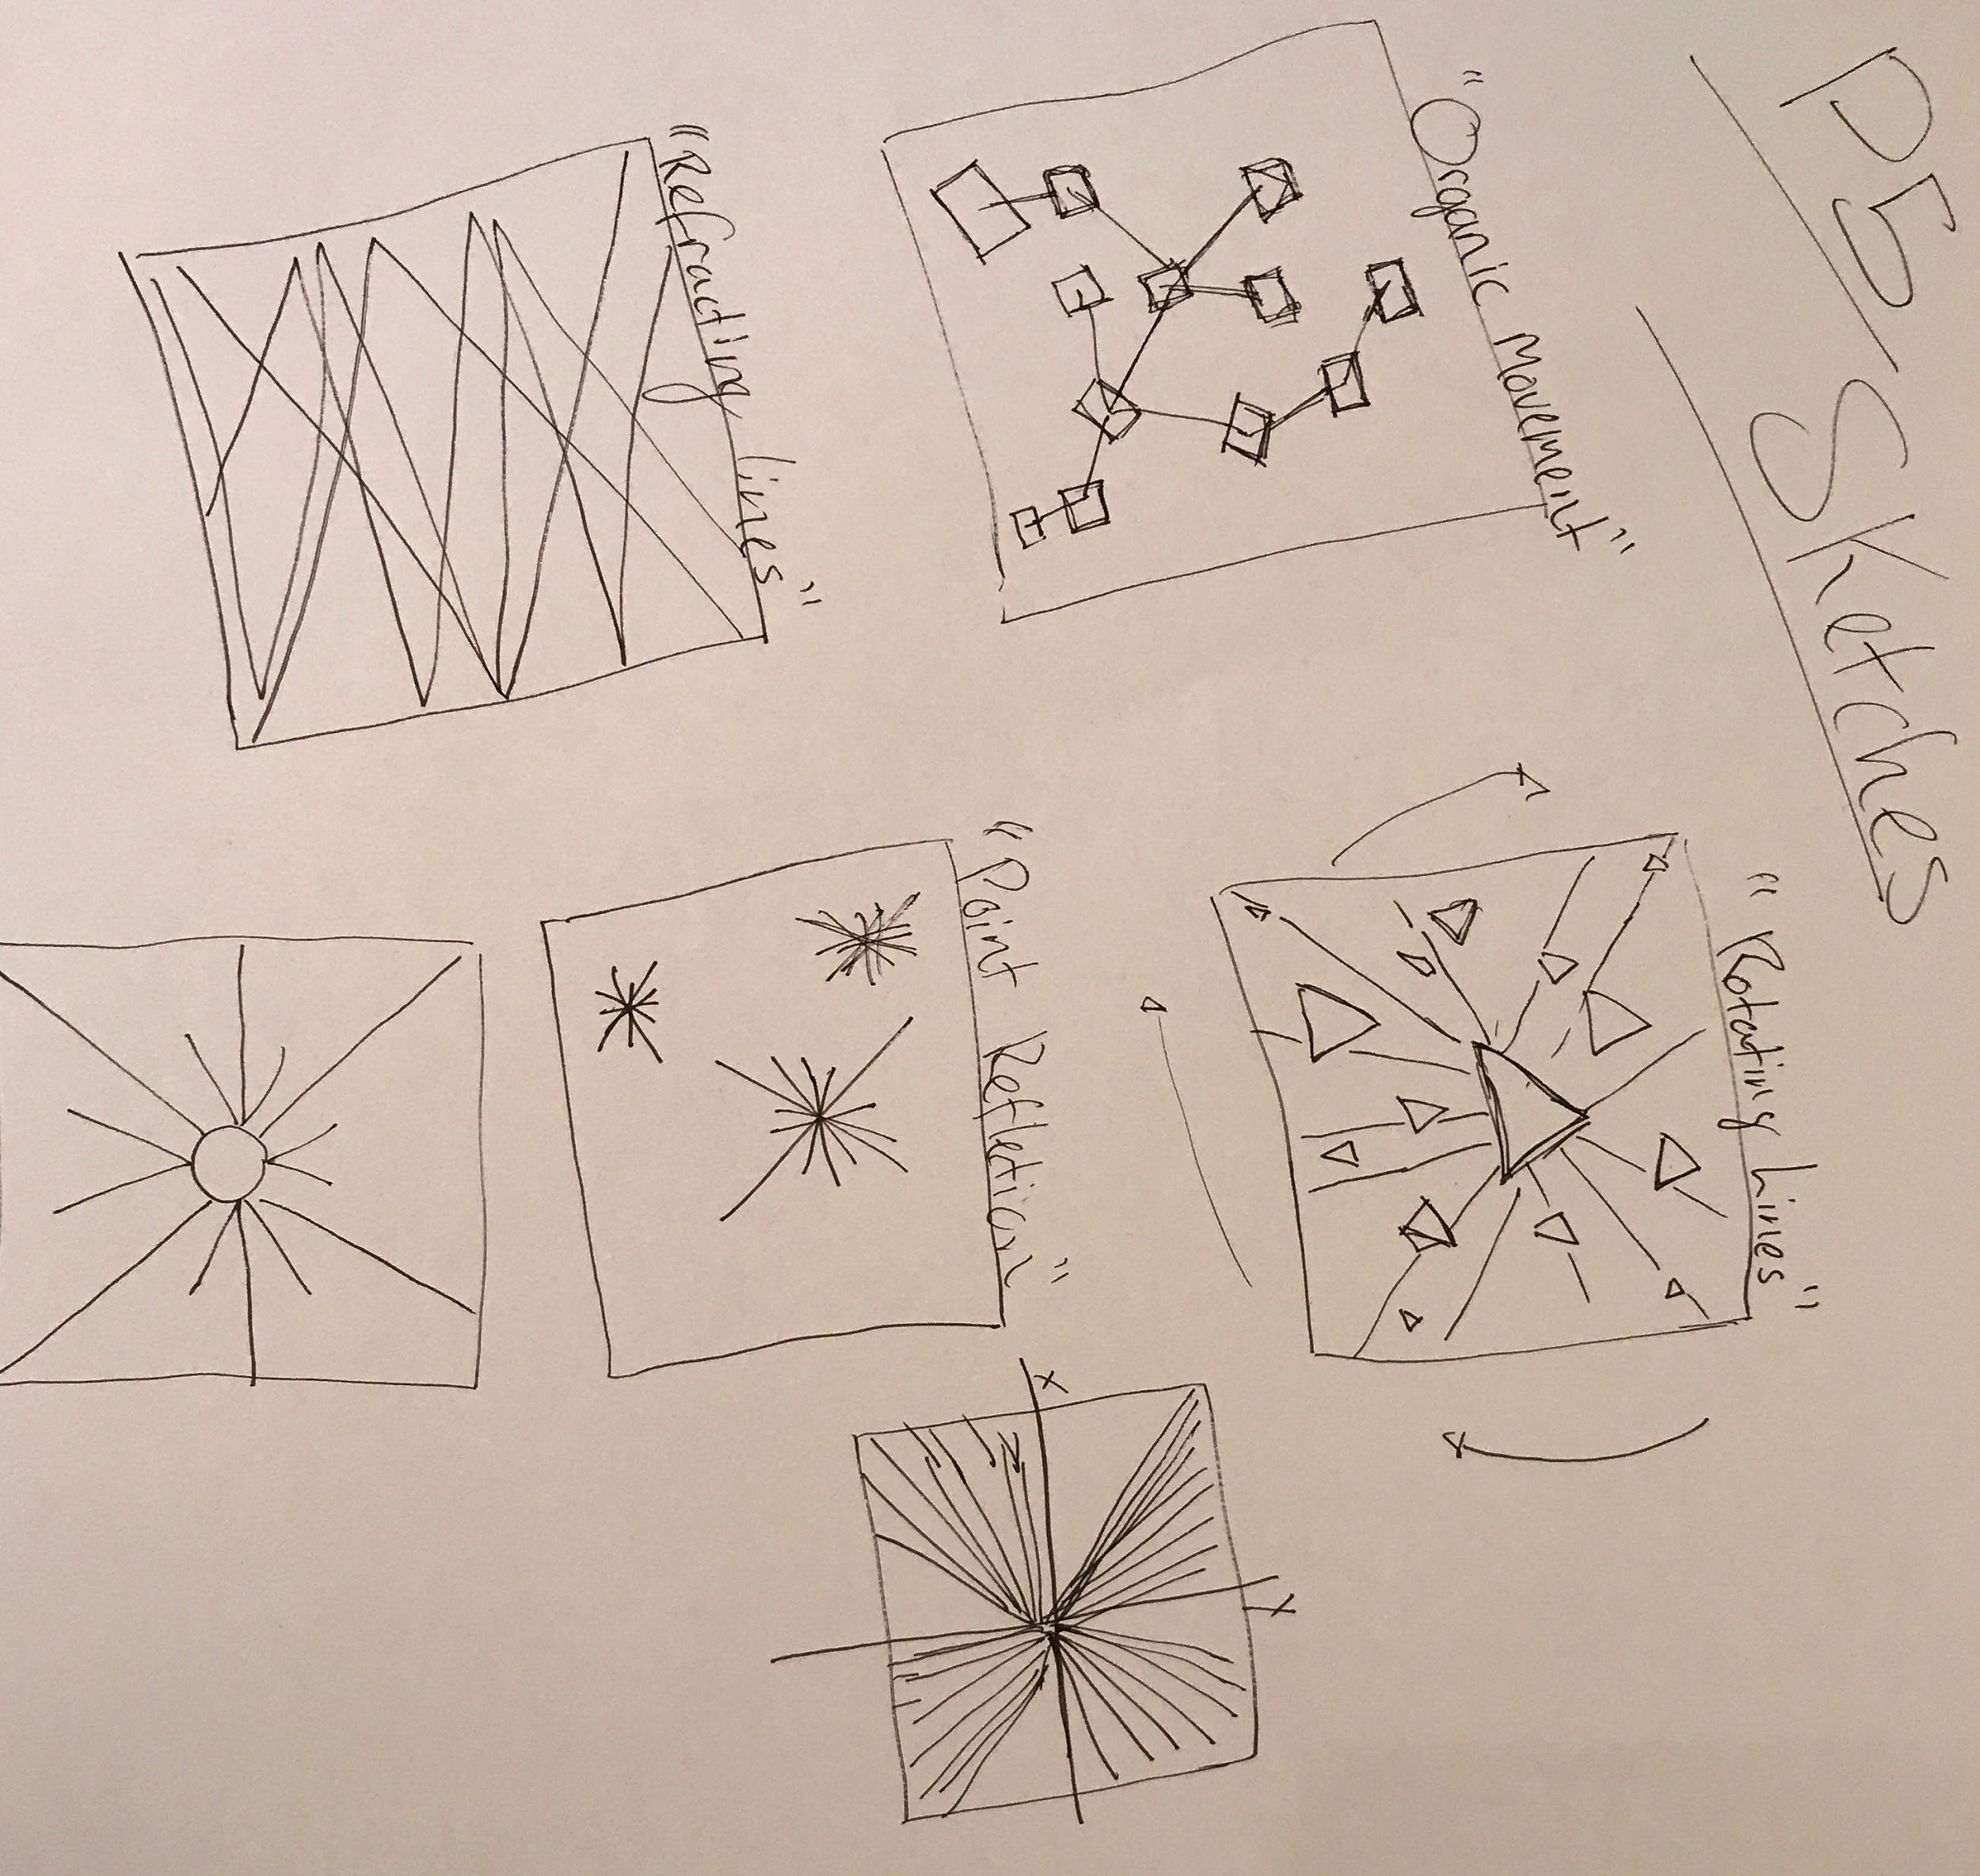

*Here is where I started with some very quick sketchs of possible paths I could take my project on. From here I moved on to actual practice with making mock ups and experimenting with different things I could do with the knowledge I had.*

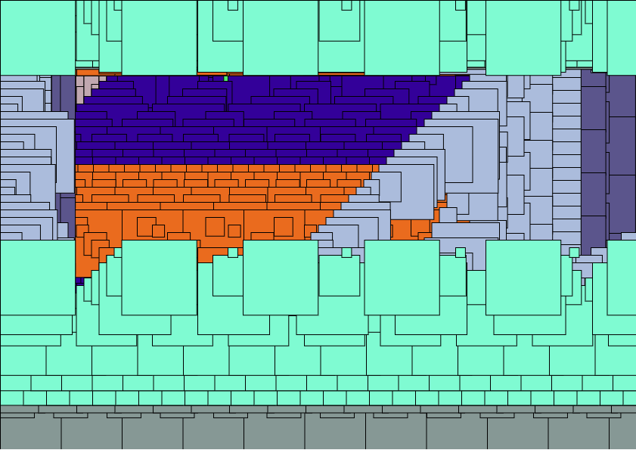

*Using stuff that I had prevoisly leant in lectures and practiced with (can be found within the Exercises and Assignment test / Assignment 1 Tests), the image above was my first design idea. It uses randomly sized squares to create paths that reflect off of the sides of the canvas; each time it hits the side of the canvas the square changes colour.*

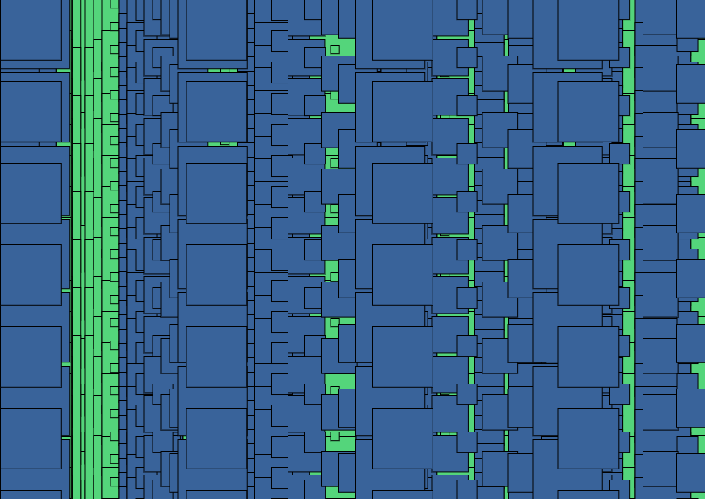

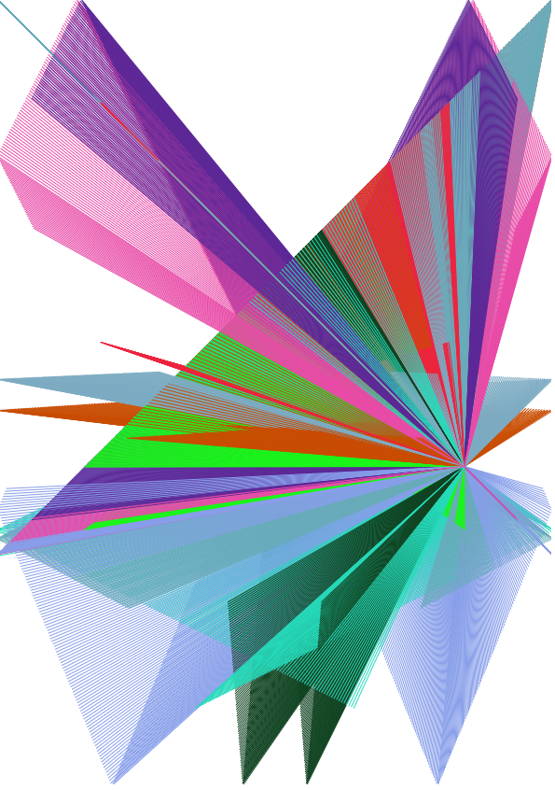

*My second design switched over to my inital idea of using lines. At this point I had not yet added the ‘mirror’ affect that I wanted to incorperate into my design. I felt this was alot stronger as a project when compared to the random squares.*

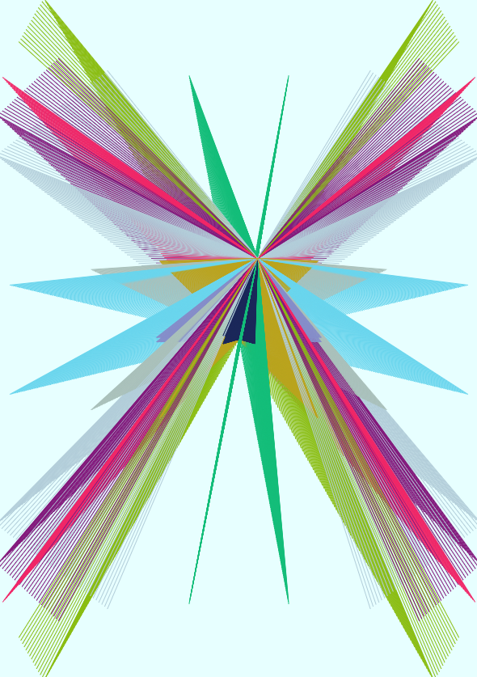

*This is what I then moved onto after adding the mirrored affect. From here I then went on to add in user interaction to the project.*

* ***Issues I faced and future upgrades I would like to make...***

*My biggest issues with this project was thinking of interaction. I came up with the idea for interaction by switching the X / Y values to change the direction of the lines as well as giving the user the ability to increase the speeds at which the lines move. Later on I also added the ability to delete lines, and reset the speed. Upgrades wise, I would like to add some interaction with the mouse; such as the center point of all the lines following the mouses location.*

**Images Of My Project.**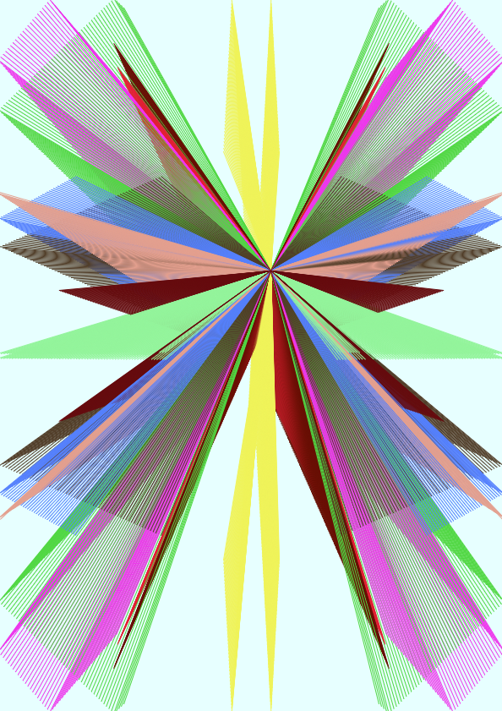

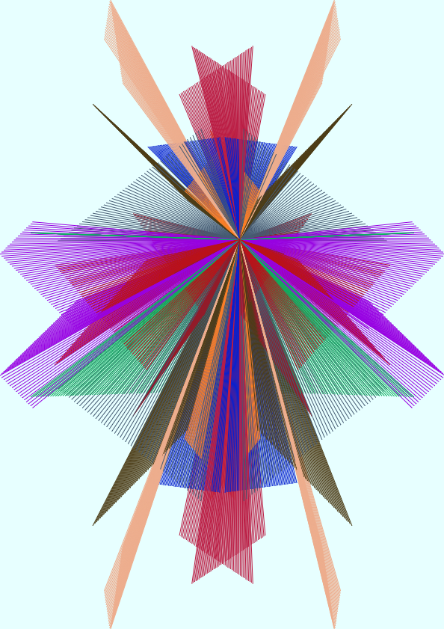

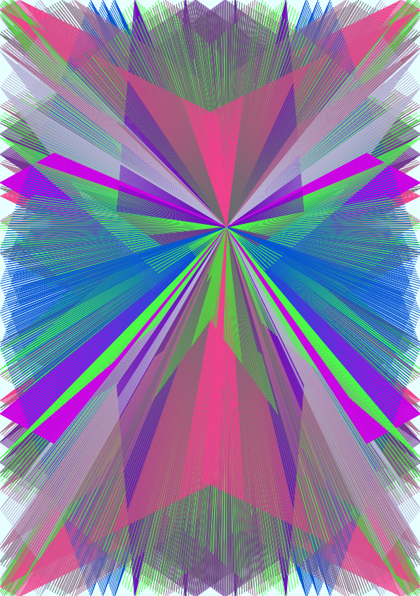

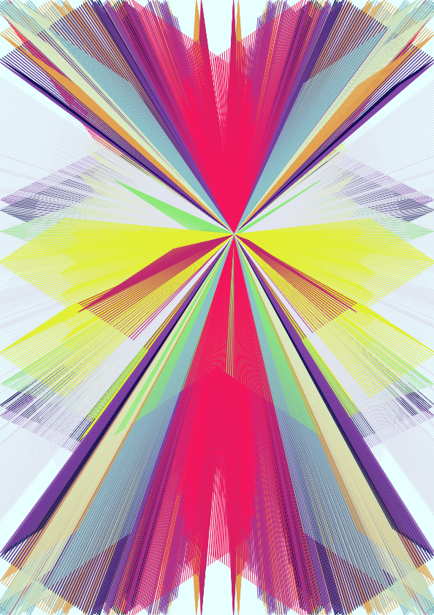

**My GitHub Page**

[*https://thomaskerslake.github.io/*](https://thomaskerslake.github.io/)

**References**

Browse Sketches - OpenProcessing. 2017. Browse Sketches - OpenProcessing. [ONLINE] Available at: <https://www.openprocessing.org/browse#>.

Processing Network - OpenProcessing. 2017. Processing Network - OpenProcessing. [ONLINE] Available at: <https://www.openprocessing.org/sketch/111878>.

mirrored lines - OpenProcessing. 2017. mirrored lines - OpenProcessing. [ONLINE] Available at: <https://www.openprocessing.org/sketch/119963>.

[ vision ] - OpenProcessing. 2017. [ vision ] - OpenProcessing. [ONLINE] Available at: <https://www.openprocessing.org/sketch/481014>.